 |  |  |  |  |  |  |  |  |  |  |  | Tree nuts |  |  |  |  |  |  |  |  | Gluten containing cereals
Menu item |  |  | Milk (dairy) | Egg | Fish | Crustacean | Mollusc | Sesame | Lupin | Peanut | Soy | Almond | Brazil nut | Cashew | Hazelnut | Macadamia | Pecan | Pine nut | Pistachio | Walnut | Wheat | Gluten | Barley | Oats | Rye
 |  |  |  |  |  | 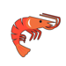 |  |  |  | 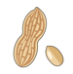 |  | 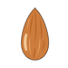 | 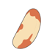 |  | 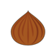 |  | 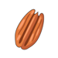 |  | 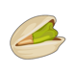 |  | 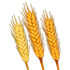 |  | 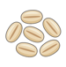 | 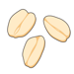 | 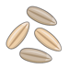
Brownie |  |  | x | x
Rhubarb muffin |  |  | x | x |  |  |  |  |  |  |  |  |  |  |  |  |  |  |  |  | x | x
amaretti |  |  |  | x |  |  |  |  |  |  |  | x
Peanut butter cookie |  |  | x | x |  |  |  |  |  | x |  |  |  |  |  |  |  |  |  |  | x | x |  | x
4-seed cookie |  |  | x | x |  |  |  | x |  |  |  |  |  |  |  |  |  |  |  |  | x | x |  | x | x
Lemon and elderflower cake |  |  | x | x |  |  |  |  |  |  |  |  |  |  |  |  |  |  |  |  | x | x
Plum and almond cake |  |  | x | x |  |  |  |  |  |  |  | x
Tiffin |  |  |  |  |  |  |  |  |  |  |  |  |  |  |  |  |  |  |  |  | x | x
Coffee cake |  |  | x | x |  |  |  |  |  |  |  |  |  |  |  |  |  |  |  |  | x | x

